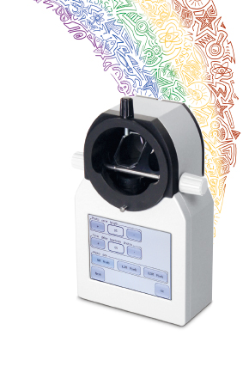
IS-6000
VIDEO SYSTEM FOR SLIT LAMP
3.5’’ LCD colour touch screen
Digital zoom & 3 resolutions
Software for digital documentation
Image and video recording
LED backlight illumination (variable)
Integrated SD card slot
Up to 5 Mpx

